**Name**: Mohamed Hazem Ahmed Ragab

**B.N**: 686

**Topic**: Database Systems

**GitHub Link**: https://github.com/MohamedHazem83/ECE001

**GitHub Pages:** https://mohamedhazem83.github.io/ECE001/

*Definition of Database Systems:*

A Database management system is a computerized record-keeping system. It is a repository or a container for collection of computerized data files. The overall purpose of DBMS is to allow the users to define, store, retrieve and update the information contained in the database on demand. Information can be anything that is of significance to an individual or organization.

*Applications of Database Systems:*

It used in Universities For student information, course registrations, colleges and grades.

It used in Telecommunication for helping to keep call records, monthly bills, maintaining balances, etc.

It used in Finance For storing information about stock, sales, and purchases of financial instruments like stocks and bonds.

*Source Code:*

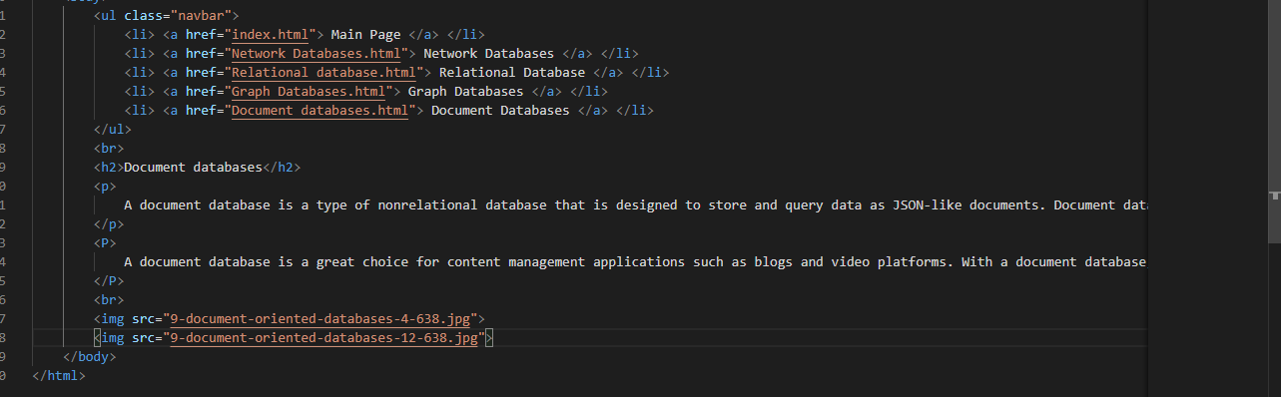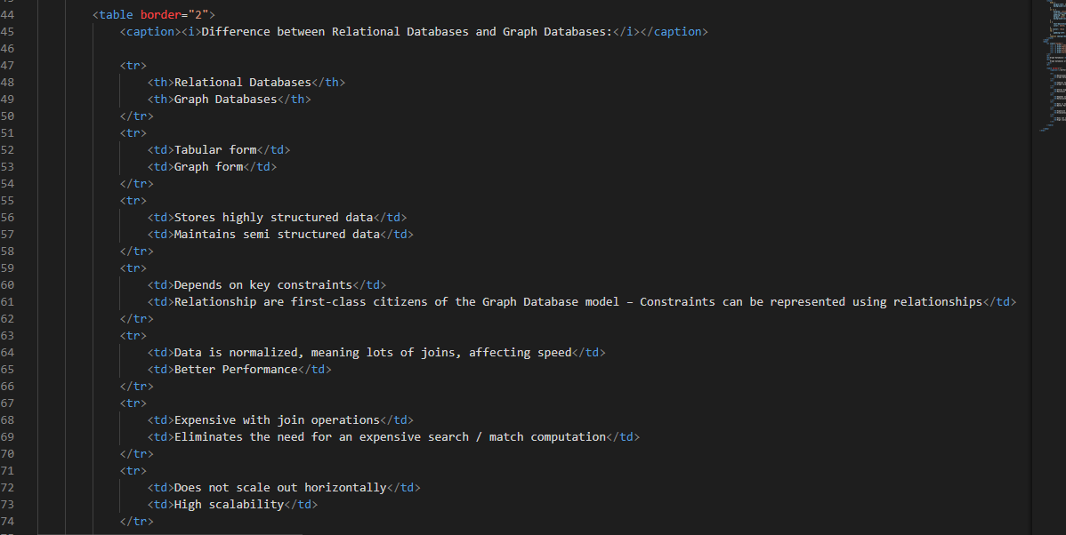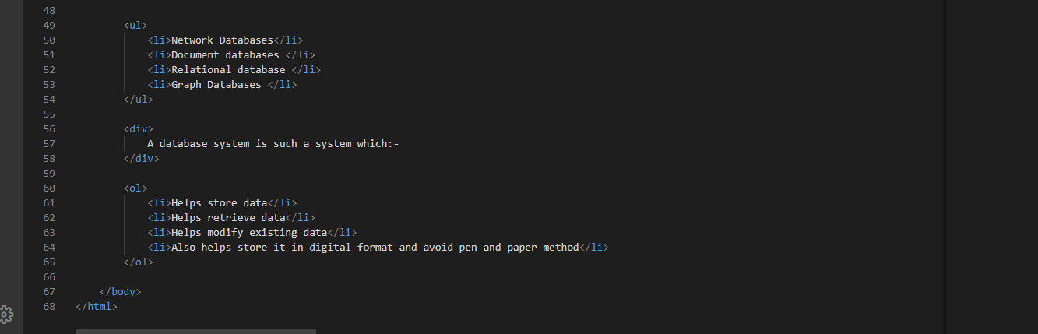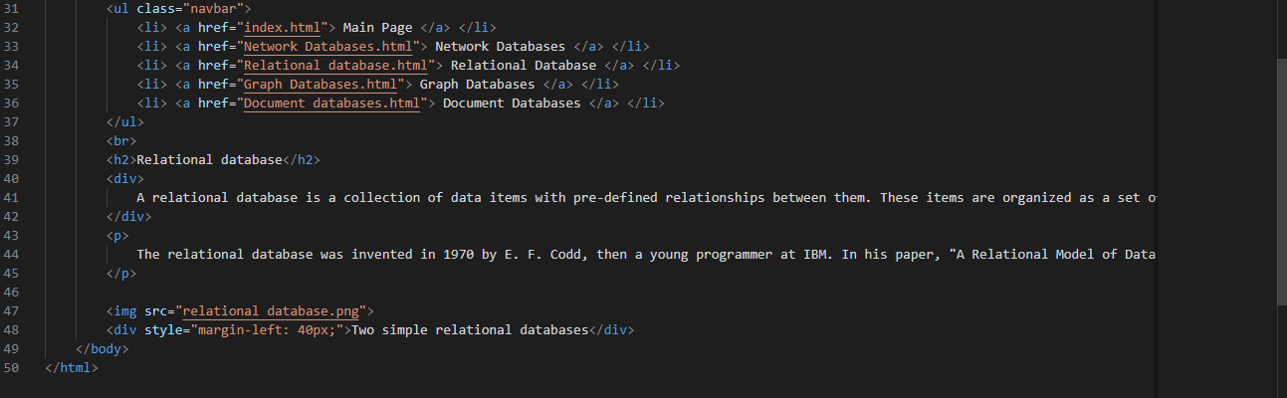

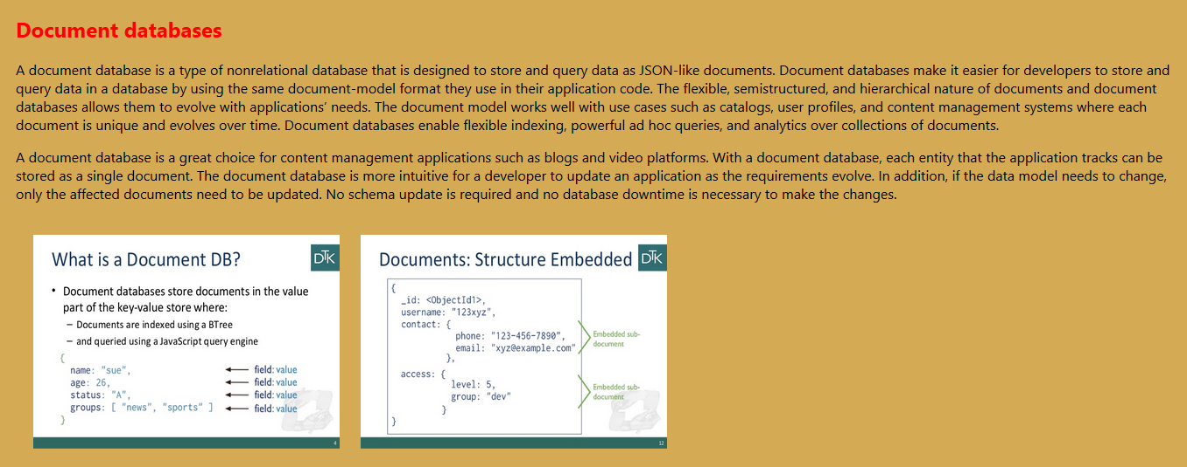*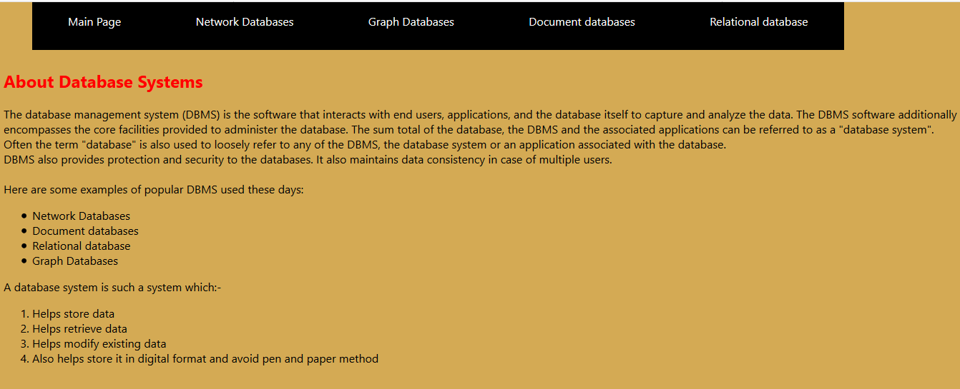Screenshots*:

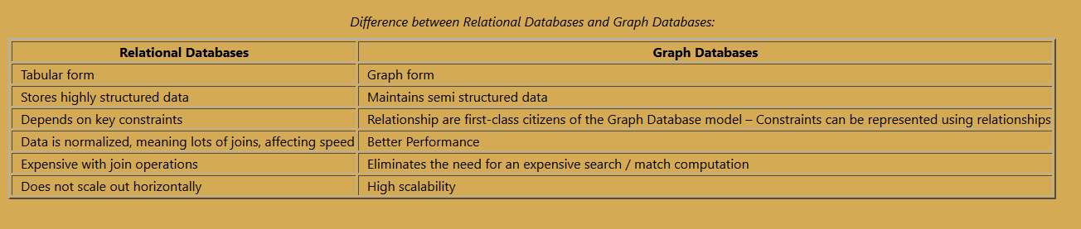

**References**

<https://www.quora.com/What-is-database-system>

<https://www.guru99.com/what-is-dbms.html>

<https://www.includehelp.com/dbms/types-of-database-management-system.aspx>

<https://www.tutorialspoint.com/Types-of-databases>

<https://codebots.com/continuous-modernisation/types-of-databases-and-dbms-with-examples>